Pls contact us :35007117@ qq.com
----------------------------------------------------------------------------------
Tilt-Switch

Introduction
The tilt switch used here is a ball one with a metal ball inside. It is used to detect the small angle of inclination.

Components
- 1 * Kuman Uno board
- 1 * USB data cable
- 1 * Tilt switch
- Several jumper wires

Experimental Principle
The principle is very simple. When the switch tilts in a certain angle, the inside ball rolls down and touches the two contacts which is connected to the outside pins, thus triggering circuits. Otherwise the ball will stay away from the contacts, thus breaking the circuits.

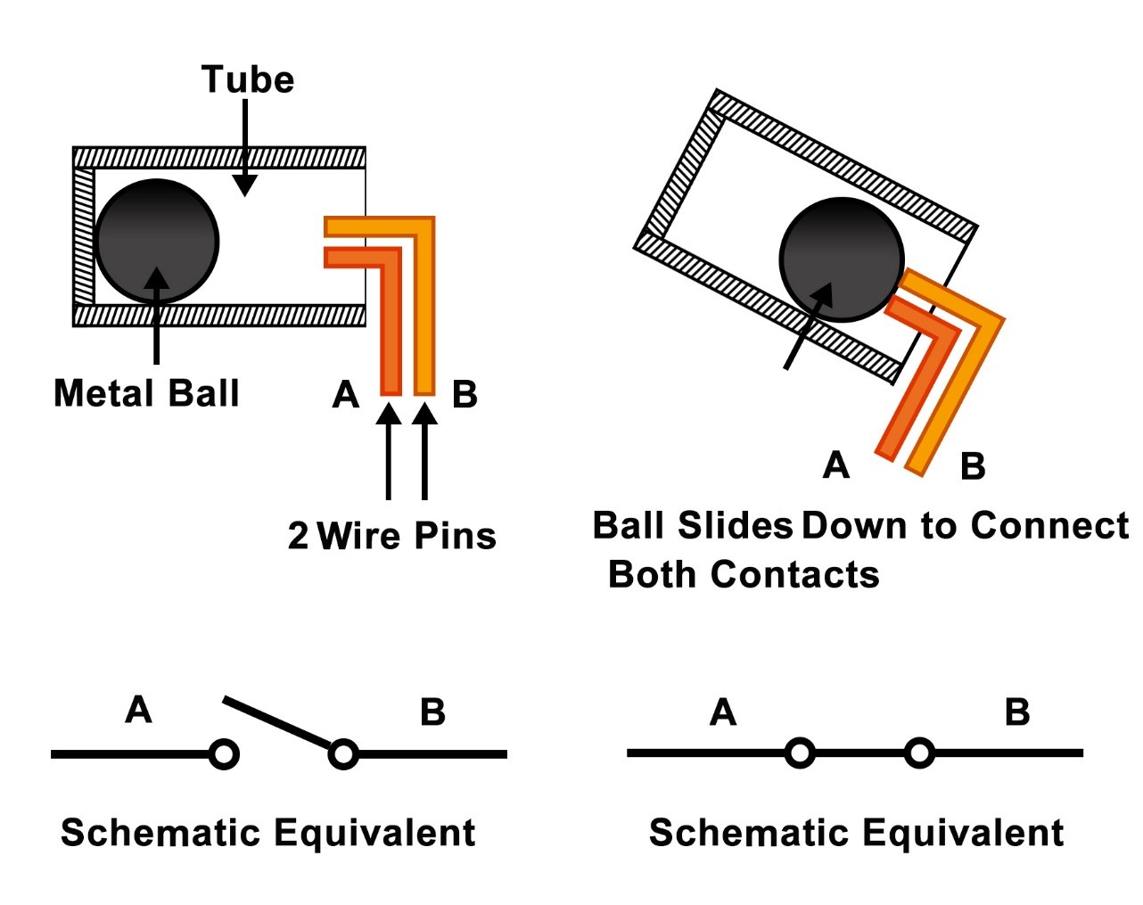

Experimental Procedures
Step 1: Build the circuit
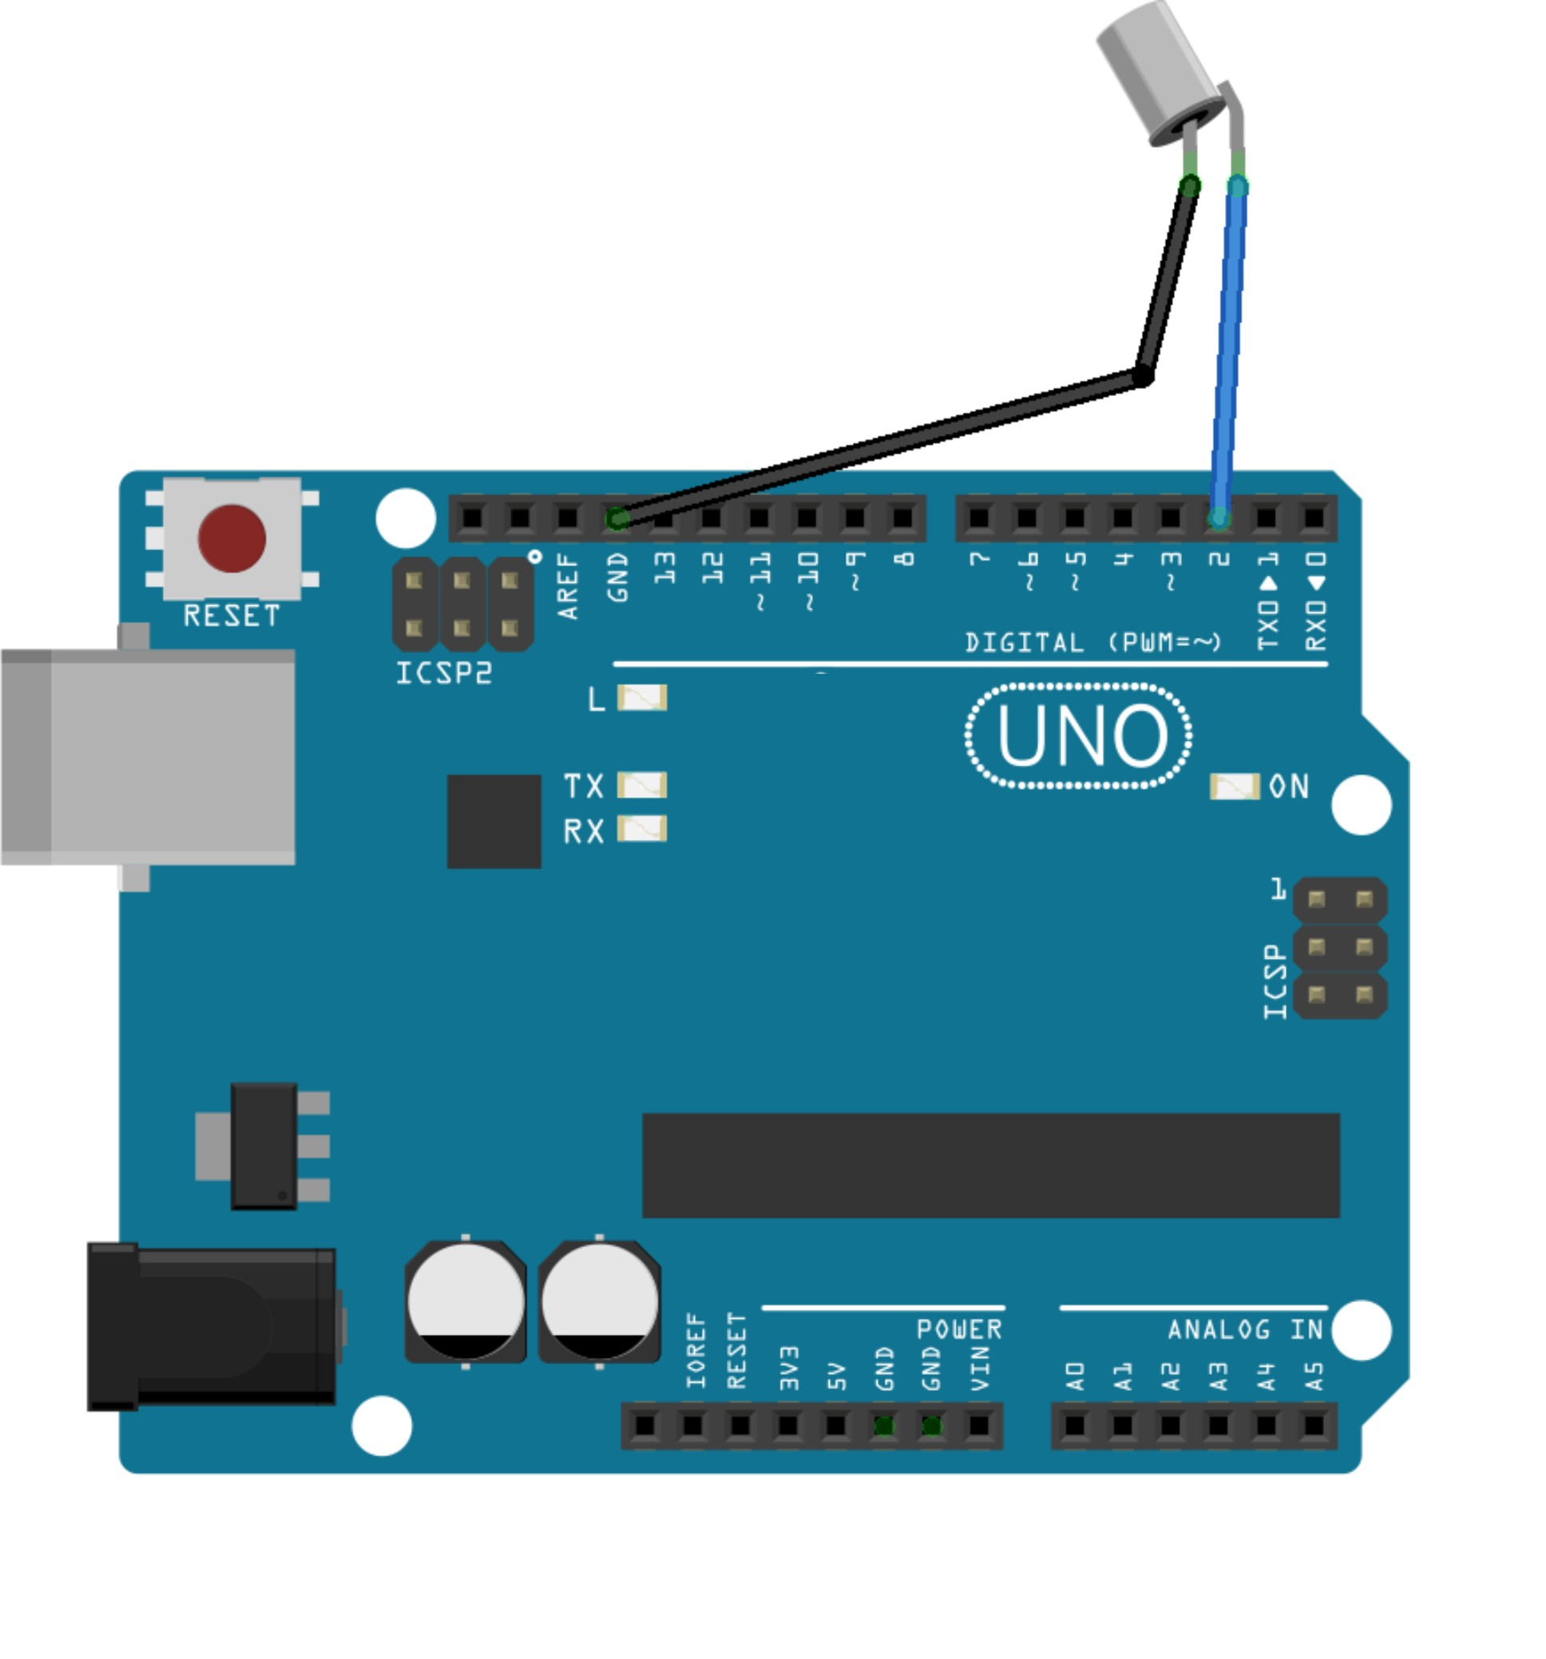

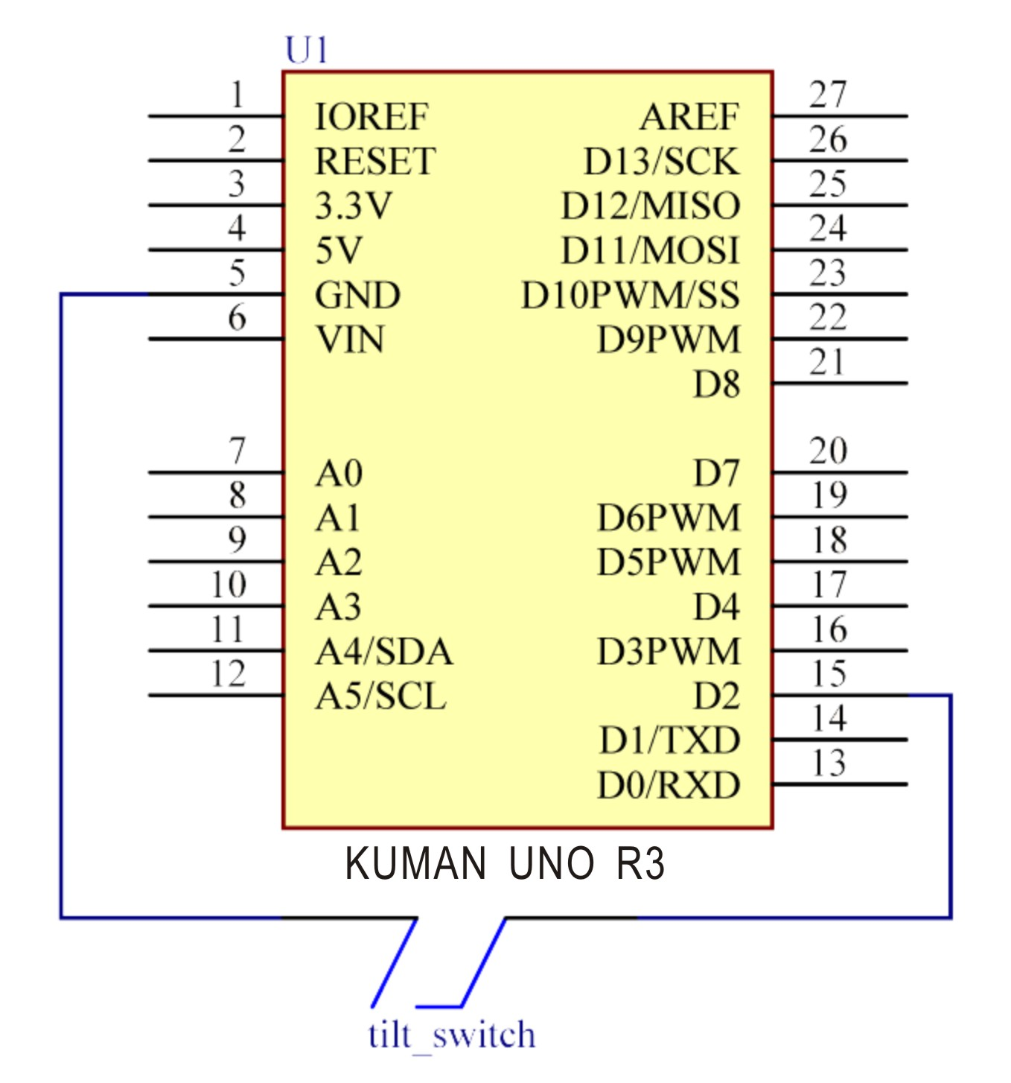

Step 2: Compile the code
Step 3: Upload the sketch to the KUMAN Uno board

Now, tilt the switch, and the LED attached to pin 13 on Kuman Uno board will light up.

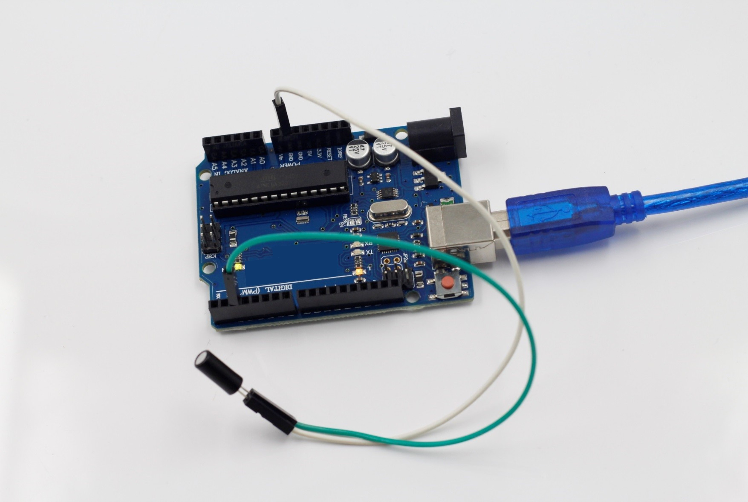

Code
//tilt switch
//tilt the switch, and the LED attached to pin 13 on SunFounder Uno board will light up.
//tilt switch attach to pin2
//Email: support@sunfounder.com
//Website: www.sunfounder.com
/*****************************************/
const int ledPin = 13;//the led attach to
void setup()
{
pinMode(ledPin,OUTPUT);//initialize the ledPin as an output
pinMode(2,INPUT);//set pin2 as INPUT
digitalWrite(2, HIGH);//set pin2 as HIGH
}
/******************************************/
void loop()
{
int digitalVal = digitalRead(2);//Read the value of pin2
if(HIGH == digitalVal)//if tilt switch is not breakover
{
digitalWrite(ledPin,LOW);//turn the led off
}
else ////if tilt switch breakover
{
digitalWrite(ledPin,HIGH);//turn the led on
}
}
/*****************/

